Operations
Research
Project

Team Members:-
- Alen Binoj MDL24CSBS012

A. Problem Definition

A1. Project Title
Cost-Optimal GPU Provisioning and Workload Allocation for AI Inference Using Operations Research

A2. Problem Statement
An enterprise operates multiple internal AI services, including customer support chatbots, document search and summarization systems, and offline code-audit batch jobs. These services use open-source large language models deployed across heterogeneous cloud GPU instances, such as NVIDIA T4, A10G, A100, and H100 GPUs. Each GPU type differs in hourly rental cost, video memory (VRAM) capacity, memory bandwidth, and inference throughput.
The demand for these AI services fluctuates over time, while individual requests vary in context length, processing requirements, and latency deadlines. Maintaining excessive GPU capacity can result in unnecessary cloud expenditure, whereas insufficient capacity or inefficient workload allocation can cause processing delays, memory limitations, and service-level agreement (SLA) violations.
The problem is to develop an Operations Research optimization model that determines the number and types of GPU instances to activate during each planning interval and allocates workloads to suitable GPU types. The objective is to minimize total GPU operating costs while satisfying workload demand, GPU memory and processing capacity constraints, throughput requirements, and latency deadlines represented in the model.
The proposed solution will be implemented using Python and Mixed-Integer Linear Programming (MILP), with the PuLP library and CBC solver. The model's performance will be evaluated using numerical results, comparisons with a baseline allocation strategy, and sensitivity analysis under different workload and cost scenarios.

A3. Real-World Context
Large language models are increasingly used in enterprise applications such as customer support automation, knowledge retrieval, document summarization, and software code analysis. Deploying these models for inference requires substantial computational resources, often provided through cloud-based GPU instances.
Cloud providers offer GPUs with different performance characteristics and rental costs. For example, NVIDIA T4 GPUs may be suitable for certain lighter workloads, while A10G, A100, and H100 GPUs can offer different combinations of memory capacity and inference performance for more demanding workloads. The suitability of each GPU depends on the model, precision, context length, batch size, and service requirements.
Enterprise workloads also vary over time. During periods of high demand, additional GPU capacity may be necessary to maintain service quality. During quieter periods, keeping all provisioned GPUs active may result in underutilization and unnecessary costs. Furthermore, latency-sensitive chatbot requests and less time-critical batch jobs may require different resource allocation strategies.
This creates a resource allocation problem involving competing objectives and constraints. Operations Research techniques can help determine cost-effective GPU provisioning and workload assignments based on workload demand, resource capacities, performance estimates, and service requirements.

A4. Significance of the Problem
The significance of this problem lies in the increasing computational cost of deploying large language models in enterprise environments. Efficient GPU resource management can help organizations reduce unnecessary cloud expenditure while maintaining the performance and reliability of their AI services.
The proposed optimization model has the following potential benefits:
- Cost reduction: Identifies lower-cost GPU configurations that can satisfy the specified workload requirements.
- Improved resource utilization: Reduces unnecessary provisioning and helps allocate workloads to suitable GPU types.
- Demand-responsive provisioning: Supports decisions about GPU capacity under varying workload demand across planning intervals.
- Performance and SLA compliance: Incorporates throughput, memory capacity, and appropriately modelled latency requirements into allocation decisions.
- Data-driven decision-making: Replaces simple fixed provisioning or naive routing with a systematic mathematical optimization approach.
- Scalability and adaptability: Provides a foundation for testing additional GPU types, workload categories, demand patterns, and cost scenarios.
From an Operations Research perspective, this problem demonstrates how mathematical modelling and optimization algorithms can be applied to a modern cloud computing challenge. The results can help quantify the trade-off between infrastructure cost and service performance under the assumptions of the model.

B. Mathematical Model

B1. Understanding the model before writing equations
Imagine that an enterprise has three GPU types available:
- T4 — lower-cost GPU
- A10G — intermediate option
- A100 — higher-capacity option
It also has three workload classes:
- Chatbot requests — strict response deadlines
- Document summarization — potentially memory-intensive
- Code-audit jobs — suitable for batch processing
For each planning interval, the model must decide:
- How many GPUs of each type should be active?
- How much workload should be assigned to each GPU type?
- Whether the chosen configuration can process the required workload within the modelled resource and deadline limits.
The objective is to minimize the total cost of the selected GPU instances, subject to all required constraints.
For our first implementation, we'll use a simplified, time-indexed MILP model with estimated processing capacities and precomputed workload feasibility. This will let us generate actual solver outputs without pretending to simulate every detail of an LLM serving system.

B2. Decision Variables
Decision variables are the unknown values that the optimization model must determine.
We'll use the following notation.

Symbol | Meaning
$g$ | GPU type, such as T4, A10G, or A100
$w$ | Workload class, such as chatbot, summarization, or code audit
$t$ | Planning interval, such as a particular hour
$x_{g,t}$ | Number of active GPUs of type $g$ during interval $t$
$z_{g,w,t}$ | Number of workload units of class $w$ assigned to GPU type $g$ during interval $t$

The primary decision variables are:

$x_{g,t}∈Z_{≥0}$
$z_{g,w,t}∈Z_{≥0}$
Here, $Z_{≥0}$ means non-negative integers.
Example: If the solver returns $x_{A10G,t}=2$, it means two A10G GPU instances should be active during that planning interval.
If it returns $z_{A10G,chatbot,t}=150$, it means 150 units of chatbot workload are assigned to the A10G tier during that interval.
For the initial model, a workload unit will represent one request or one defined batch of jobs, depending on the workload class. We'll define this consistently in the input data.

B3. Objective Function
The objective function specifies what the model is trying to optimize.
Our goal is to minimize the total GPU rental expenditure over the planning horizon.
Let:
- $c_{g}$ = rental cost per hour of GPU type $g$.
- $x_{g,t}$ = number of active instances of GPU type $g$ in interval $t$.
- $Δt$ = duration of each planning interval in hours.
- $T$ = set of planning intervals.
- $G$ = set of available GPU types.
The objective function is:
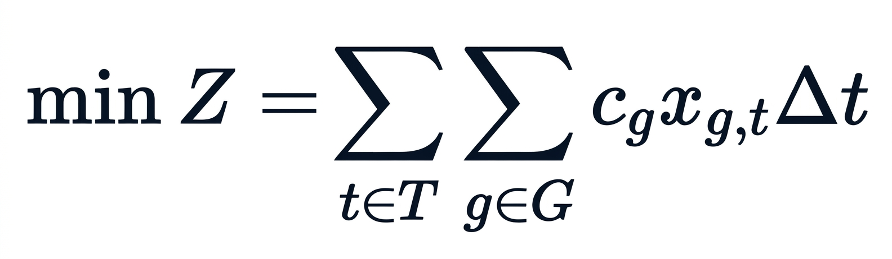
Here, $Z$ represents the total GPU rental cost over the planning horizon.

Example
Suppose two A10G instances are active for one hour, and each costs ₹40 per hour.

$Cost=2×40×1=₹80$
If those instances remain active for four hours, their rental cost becomes ₹320.
The solver will seek the least expensive combination of GPU types and instance counts that satisfies all the constraints.
For this first version, we'll exclude model-hosting overheads, data transfer costs, and instance startup charges. They can be added later if the required data is available.

B4. Constraints
Constraints define the conditions that every valid solution must satisfy. Without them, the solver could minimize cost simply by activating zero GPUs.

1. Demand satisfaction constraint
Every workload must be processed.
Let $d_{w,t}$ represent the number of workload units of class $w$ that must be processed during interval $t$.
The constraint is:
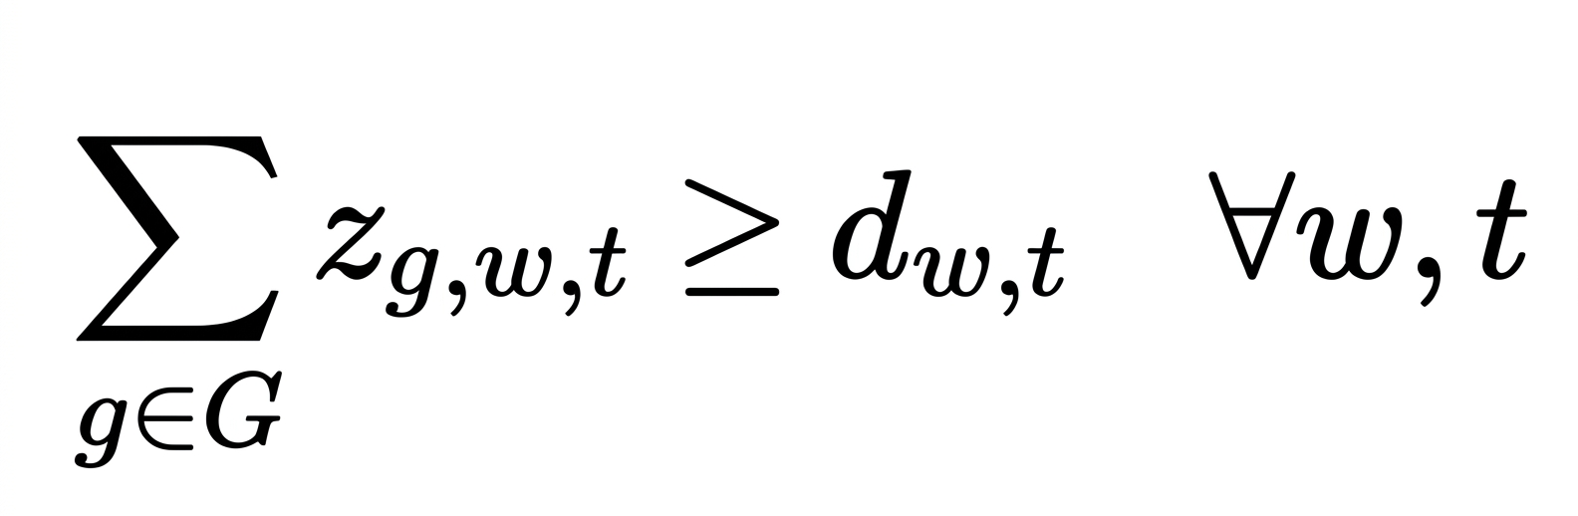
This means that the total workload allocated across all GPU types must meet the required demand.
Example: If 500 chatbot requests must be handled during an interval, the sum of chatbot requests allocated across the eligible GPUs must be at least 500.
For our initial model, we'll assume demand must be handled within its designated interval rather than allowing requests to carry over indefinitely.

2. GPU processing-capacity constraint
Each GPU has limited processing capacity. We need to prevent the model from assigning more work to a GPU fleet than it can process during the available time.
Let:
- $s_{g,w}$ = estimated processing time per workload unit of class $w$ on GPU type $g$, measured in GPU-seconds.
- $H_{t}$ = duration of interval $t$, measured in seconds.
Then:
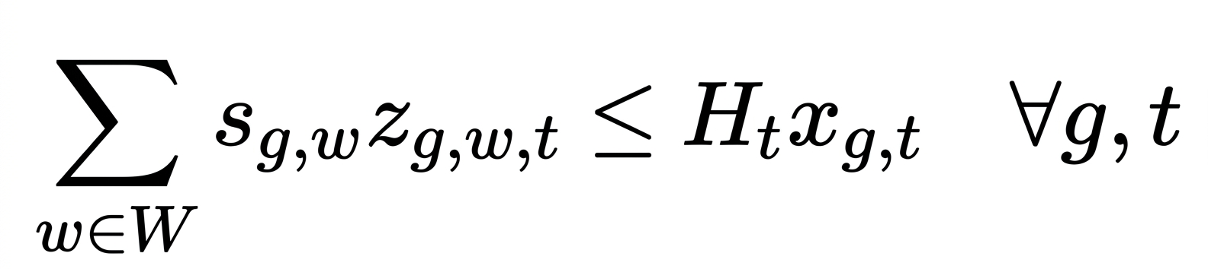
The left-hand side represents the total estimated GPU processing time required by the assigned workloads. The right-hand side represents the processing time available from the active GPU instances.
For example, if one GPU is available for one hour, it provides 3,600 GPU-seconds of processing capacity under this simplified model.
This formulation assumes processing times are additive and that workload interference and concurrency effects are adequately approximated by the input estimates.

3. GPU memory-feasibility constraint
A GPU should only receive workloads that fit within its memory capacity.
Let $a_{g,w}$ be a binary compatibility parameter:
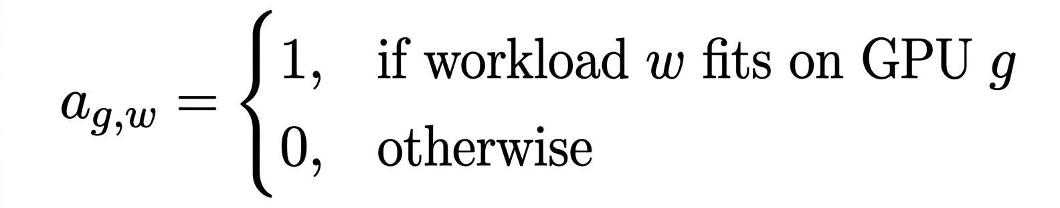
Let $M_{w,t}$ be a sufficiently large upper bound on the number of workload units of class $w$ that may be assigned during interval $t$.
We impose:
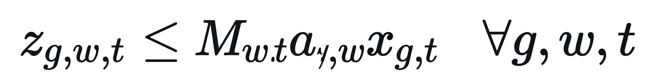
If a workload does not fit on a GPU, then $a_{g,w}=0$, forcing its assignment to that GPU type to be zero.
If a GPU type is not active, then $x_{g,t}=0$, which also prevents workload assignment to it.
In practice, compatibility should be determined using the model's VRAM requirements, including model weights, runtime memory, and KV-cache requirements for the relevant context length and batch size. We should not assume that a GPU is compatible merely because its nominal VRAM exceeds the model's parameter size.

4. Latency-deadline constraint
Some workloads have strict latency requirements. Our model must avoid assigning requests to GPU types that cannot meet their estimated service deadlines.
Let:
- $L_{w}$ = maximum allowed service time for workload class $w$.
- $L_{g,w}$ = estimated service time for workload class $w$ on GPU type $g$.
- $b_{g,w}$ = a binary parameter equal to 1 if the estimated service time meets the deadline and 0 otherwise.
Define:
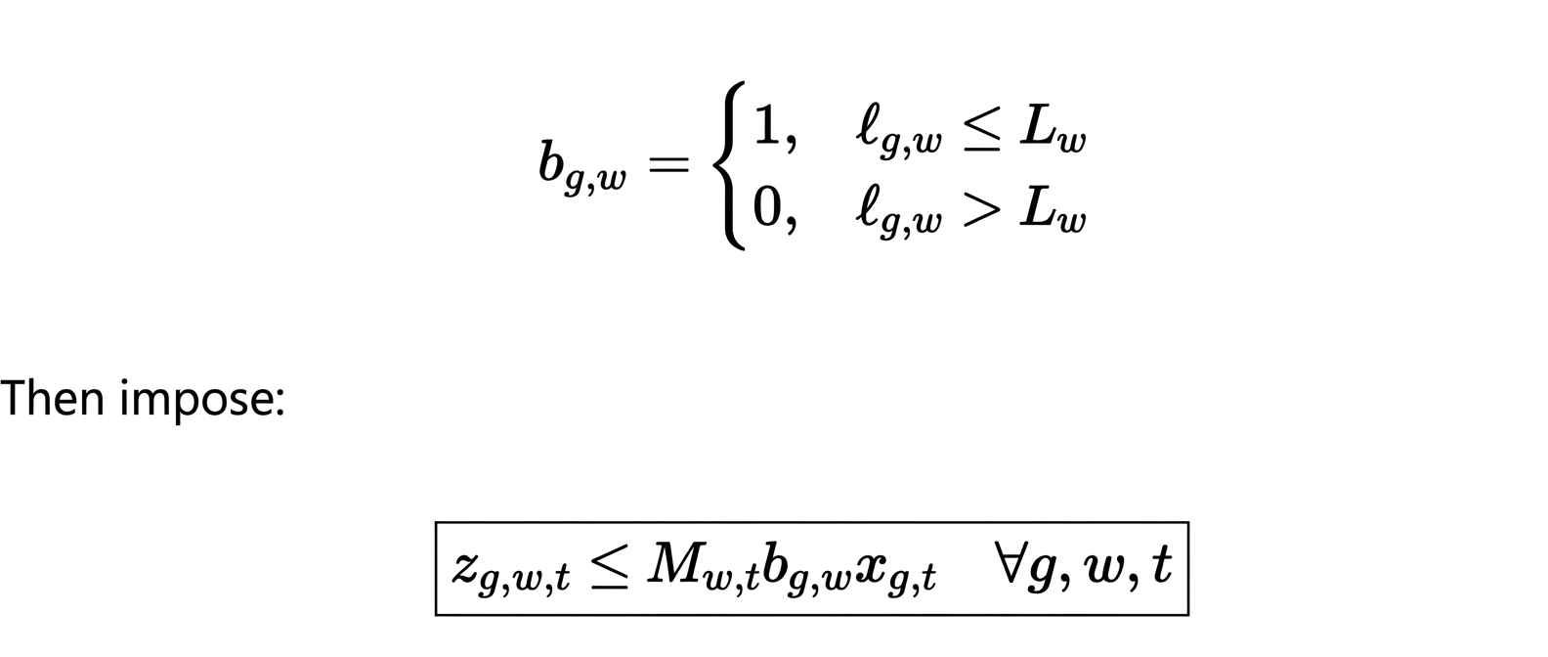
This prevents requests from being assigned to GPU types that fail the modelled deadline test.
Important limitation: This constraint checks estimated service-time feasibility. It does not, by itself, guarantee end-to-end latency under queueing, network delays, or concurrent inference. We must describe it as a simplified latency-feasibility model, not as a complete real-time serving simulation.

5. GPU availability constraint
The enterprise may have a limit on the number of instances it can rent or deploy.
Let $U_{g}$ be the maximum number of available instances of GPU type $g$.
Then:
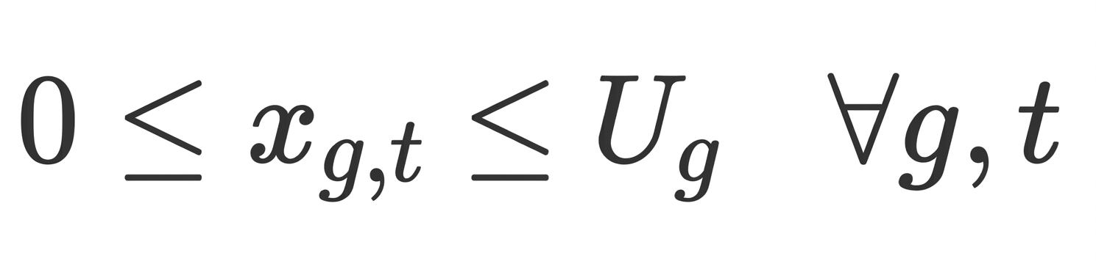
his prevents the model from selecting an unlimited number of GPUs.
If no practical limit is known, we can establish a documented upper bound that is large enough not to artificially restrict the optimal solution.

6. Integer and non-negativity constraints
GPU instance counts and workload counts cannot be negative or fractional in our initial formulation:
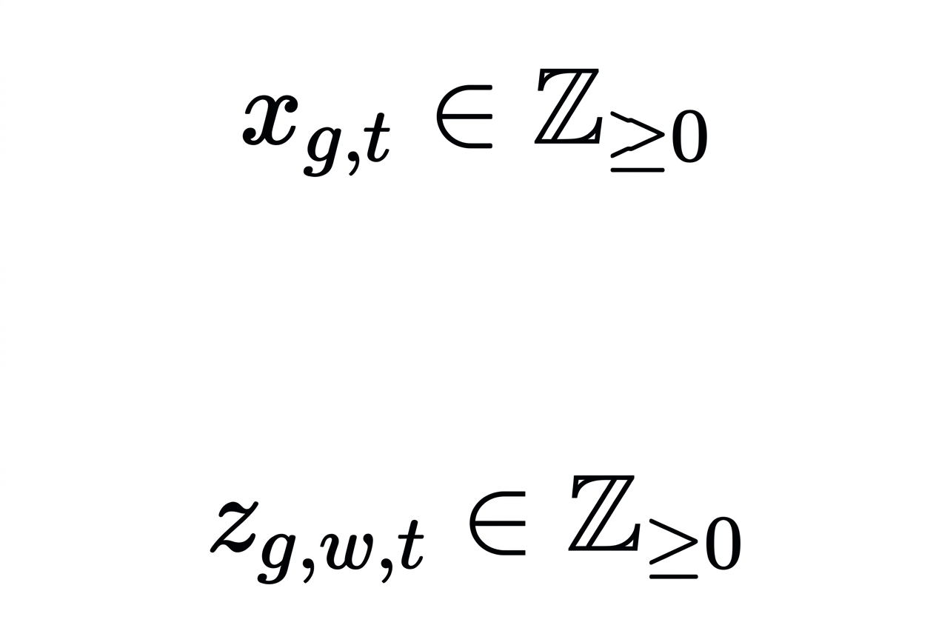
These restrictions make the formulation a Mixed-Integer Linear Programming problem, assuming the input parameters are fixed and the constraints remain linear.

B5. Complete Mathematical Formulation
Now we combine the decision variables, objective function, and constraints into one model.
Let:
- $G$ = set of GPU types.
- $W$ = set of workload classes.
- $T$ = set of planning intervals.
- $c_{g}$ = hourly rental cost of GPU type $g$.
- $d_{w,t}$ = required demand for workload class $w$ in interval $t$.
- $s_{g,w}$ = estimated GPU-seconds required per workload unit.
- $H_{t}$ = interval duration in seconds.
- $a_{g,w}$ = memory and workload compatibility indicator.
- $b_{g,w}$ = deadline feasibility indicator.
- $M_{w,t}$ = valid upper bound on workload assignments.
- $U_{g}$ = maximum available instances of GPU type $g$.
The complete formulation is:
Objective function

$\min_{}Z=\sum_{t∈T}{}\sum_{g∈G}{}c_{g}x_{g,t}Δt$
subject to:
Demand satisfaction:
$\sum_{g∈G}{}z_{g,w,t}≥d_{w,t}∀w,t$
Processing capacity:
$\sum_{w∈W}{}s_{g,w}z_{g,w,t}≤H_{t}x_{g,t}∀g,t$
Memory and workload compatibility:
$z_{g,w,t}≤M_{w,t}a_{g,w}x_{g,t}∀g,w,t$
Estimated latency feasibility:

$z_{g,w,t}≤M_{w,t}b_{g,w}x_{g,t}∀g,w,t$
Instance availability:

$x_{g,t}≤U_{g}∀g,t$
Integer and non-negativity conditions:

This is our initial cost-minimizing MILP formulation. The solver will choose the GPU instance counts and workload assignments that minimize the modeled rental cost while meeting the specified constraints.
A modelling note for the final report: this initial formulation assumes workload processing times and compatibility can be represented by fixed parameters. If batch sizes, queueing, or context lengths materially change GPU performance, we'll need more detailed input classes or an expanded model.

B6. Data Set and Data Source
Our optimization model requires input data describing GPU costs, workload demand, processing capacity, memory compatibility, and latency deadlines.
Since we do not have access to a specific enterprise's confidential inference logs, we'll initially use a documented experimental dataset. It can combine published technical specifications, benchmark-derived estimates, and clearly labelled simulated workload demand.
Data required | Example fields | Proposed source
GPU rental cost | Cost per instance per hour | Official cloud-provider pricing pages
GPU specifications | VRAM capacity, GPU model | Official NVIDIA product specifications
Processing performance | Estimated GPU-seconds per workload unit | Published inference benchmarks or controlled benchmark tests
Workload demand | Requests or batches per interval | Simulated workload scenarios
Memory requirements | Model memory and KV-cache requirements | Model documentation and calculated estimates
Latency deadlines | Maximum service time by workload class | Defined project assumptions based on service requirements
GPU availability | Maximum instances per GPU type | Defined experimental limits or provider availability

C. OR Method

C1. OR Technique Selected
Mixed-Integer Linear Programming (MILP) is selected as the Operations Research technique for optimizing GPU provisioning and workload allocation for AI inference.
MILP is a mathematical optimization technique in which the objective function and constraints are linear, while some or all decision variables are required to take integer values. In this project, integer variables represent the number of active GPU instances and the number of workload units assigned to each GPU type.
The model aims to minimize total GPU rental expenditure while satisfying workload demand, processing capacity, memory compatibility, estimated latency feasibility, and GPU availability constraints.
The model will be implemented in Python using the PuLP optimization library, with the CBC solver used to find an optimal solution for the formulated problem.

C2. Reason for Selecting the Technique
MILP is suitable for this problem for the following reasons.
1. Integer-based decisions
GPU instances cannot be rented in fractional quantities in our model. MILP supports integer decision variables for selecting the number of GPUs to activate.
2. Cost minimization
GPU rental expenditure can be expressed as a linear objective function based on the number of active instances, their hourly costs, and the duration of each planning interval.
3. Multiple constraints
MILP allows several operational restrictions to be modelled together, including workload demand, GPU processing capacity, memory compatibility, and instance availability.
4. Workload allocation
Integer variables can represent the number of requests or workload units assigned to different GPU types, allowing the model to determine a feasible allocation.
5. Computational implementation
The model can be formulated using Python's PuLP library and solved using CBC, making it practical to implement, test, and evaluate using experimental data.
6. Scenario analysis
The model can be solved repeatedly with different demand levels, GPU rental prices, and resource capacities to evaluate how the optimal allocation changes.

C3. Brief Description of the Method
MILP works by representing a decision-making problem mathematically and searching for the best feasible combination of decision variables.
In our project, the method follows these steps:
Step 1: Define input parameters
GPU costs, capacities, workload demand and deadlines
Step 2: Formulate the MILP model
Define decision variables, objective function and constraints
Step 3: Solve using CBC
Search for the minimum-cost feasible configuration
Step 4: Obtain the solution
Determine active GPU counts and workload assignments
Step 5: Evaluate the results
Calculate total cost and compare against a baseline

A simple example of how MILP makes a decision
Suppose the enterprise needs to process 500 workload units within one hour.
GPU configuration | Cost per hour | Meets demand?
5 × T4 | ₹100 | Yes
2 × A10G | ₹80 | Yes
1 × A100 | ₹80 | Yes
These are hypothetical values used only to illustrate the technique.
The model compares feasible configurations and chooses one with the lowest cost. If one configuration violates a memory or latency constraint, it must be excluded even if it is cheaper.
If two configurations have the same minimum cost, either may be optimal unless we introduce an additional objective or tie-breaking rule.

C4. How MILP relates to the implementation
The mathematical formulation from Section B maps directly to the code.

Mathematical component | Implementation in Python
Decision variables | LpVariable
Objective function | lpSum() of GPU costs
Constraints | PuLP model constraints
Optimization model | LpProblem
Solver | CBC via PULP_CBC_CMD
Optimal GPU allocation | Values returned by the solver
Minimum cost | Objective value returned by the solver
This mapping is important because the code will implement the mathematical model rather than use a separate, manually constructed allocation rule.

C5. Assumptions and applicability
The initial MILP formulation assumes that:
- GPU rental costs are known and constant within each planning interval.
- Workload demand is specified for each interval.
- GPU processing times are estimated and treated as fixed model parameters.
- Memory and latency feasibility can be represented by precomputed compatibility indicators.
- GPU instance counts and workload allocations are integer-valued.
- The objective is to minimize GPU rental costs without introducing additional objectives such as energy consumption or carbon emissions.
These assumptions make the initial problem manageable. More detailed queueing, batching, and dynamic scaling effects can be incorporated in future extensions if the required data and modelling effort permit.
One technical point: CBC finds an optimal solution only when the formulated model is feasible and the solver establishes optimality. If the constraints cannot all be satisfied, the model may instead report infeasibility.

D. Methodology & Implementation

D1. Proposed Solution Procedure
The proposed solution involves developing a Python-based optimization system to minimize GPU inference expenditure while satisfying workload and resource constraints. The system will use Mixed-Integer Linear Programming (MILP) to determine the number of GPU instances to activate and allocate workloads to suitable GPU types.
The solution procedure consists of the following stages:
- Data collection: Gather GPU rental costs, VRAM capacities, processing performance estimates, maximum instance availability, workload demand, and service deadlines.
- Data preparation: Organize GPU specifications and workload parameters using CSV files and Pandas. Convert the inputs into consistent units and establish workload-to-GPU compatibility.
- Model formulation: Define decision variables for GPU provisioning and workload allocation, formulate the cost-minimization objective, and specify demand, processing capacity, memory, latency-feasibility, and availability constraints.
- Model implementation: Translate the mathematical formulation into Python using the PuLP library.
- Optimization: Use the CBC solver to find a minimum-cost feasible solution.
- Result extraction: Obtain the selected GPU counts, workload assignments, and total modeled rental expenditure.
- Performance evaluation: Compare the optimized solution with a baseline strategy and conduct what-if analyses under different workload demands and GPU prices.
The procedure provides a systematic way to evaluate cost-effective GPU provisioning decisions using mathematical optimization.

D2. Software and Tools to Be Used
The project will use the following tools for mathematical modelling, optimization, data processing, and result visualization.
Tool | Purpose
Python | Main programming language for implementing the optimization model
PuLP | Defining the MILP objective function, decision variables, and constraints
CBC Solver | Solving the MILP to obtain an optimal feasible allocation
Pandas | Loading, processing, and analyzing GPU and workload datasets
Matplotlib | Visualizing cost comparisons, GPU utilization, and sensitivity results
CSV files | Storing GPU specifications, workload demand, and input parameters
Jupyter Notebook or VS Code | Writing, running, debugging, and documenting the implementation
The initial implementation will use experimental input data with clearly documented assumptions. Actual cloud pricing and GPU performance estimates will be incorporated where suitable sources are available.

D3. Algorithm / Flowchart
The optimization algorithm will take the GPU and workload data as inputs, formulate the MILP, execute the solver, and report the resulting allocation.

Proposed algorithm
Algorithm: Cost-Optimal GPU Provisioning and Workload Allocation
Input: GPU rental costs, GPU capacities, workload demand, processing-time estimates, memory compatibility, latency deadlines, and instance availability.
Output: Optimal GPU instance counts, workload assignments, and minimum modeled cost.
- Start.
- Load GPU specifications and workload data from CSV files.
- Validate the input data and convert values into consistent units.
- Initialize the MILP optimization model.
- Define decision variables for active GPU instances and workload allocations.
- Define the objective function to minimize total GPU rental expenditure.
- Add demand satisfaction and GPU processing-capacity constraints.
- Add memory compatibility, estimated latency-feasibility, and instance availability constraints.
- Invoke the CBC solver.
- Check the solver status.
- If an optimal solution is found, extract the GPU configuration, workload assignments, and objective value.
- Calculate baseline cost and evaluate potential savings.
- Perform sensitivity analysis by changing demand or GPU cost parameters and solving the model again.
- Display the results and generate visualizations.
- Stop.
If the model is infeasible or the solver does not establish optimality, report the appropriate status rather than presenting an unverified allocation as optimal.

Flowchart
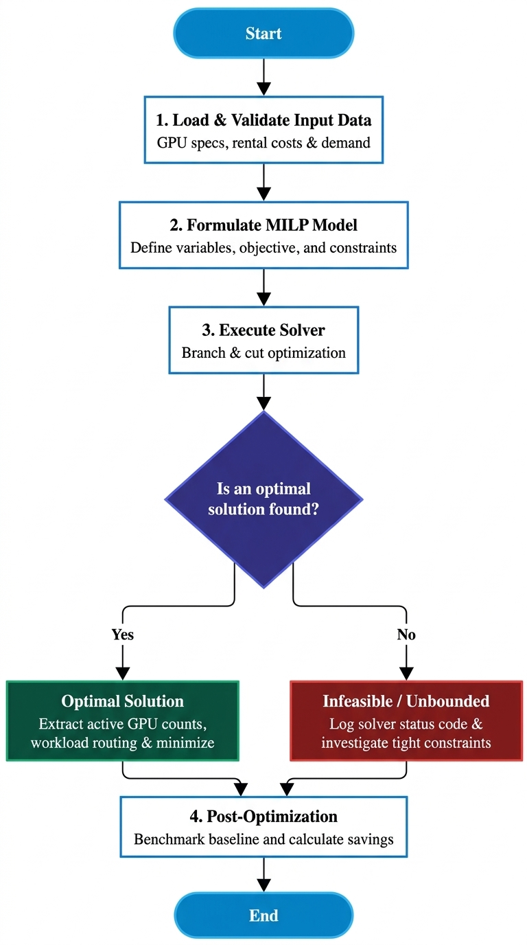

D4. Implementation Plan
The implementation will be divided into stages so that the mathematical model can be developed and tested incrementally.

1
Prepare the dataset
Create CSV files containing GPU prices, memory capacity, processing estimates, workload demand, and compatibility information.

2
Develop the optimization model
Implement the decision variables, cost objective, and constraints in PuLP.

3
Execute and debug
Run CBC, verify solver status, test constraint satisfaction, and correct any modelling or implementation errors.

4
Generate results
Display active GPU counts, workload assignments, and total modeled cost in readable tables.

5
Evaluate the solution
Compare the optimized result against a defined baseline, vary input parameters, and generate charts using Matplotlib.
The implementation will be considered successful when the program can load the input data, solve the formulated optimization problem, produce a valid allocation when one exists, and calculate the corresponding objective value.

E. Results

E.1 Expected / Preliminary Solution
The implemented optimization model was executed using Python, the PuLP library, and the HiGHS optimization solver. The model returned an optimal solution for the supplied experimental dataset.
The solution selects four NVIDIA T4 GPU instances and one NVIDIA A10G GPU instance, while no NVIDIA A100 instances are selected. This configuration satisfies the total workload demand of 650 workload units under the processing-capacity assumptions specified in the dataset.
The workload allocation returned by the model is summarized below.
Workload class | T4 allocation | A10G allocation | Total allocation
Chatbot | 300 | 0 | 300
Document summarization | 100 | 100 | 200
Code auditing | 0 | 150 | 150
Total | 400 | 250 | 650
The allocation demonstrates that different workload classes can be distributed across GPU types according to their modelled processing and compatibility requirements. Chatbot requests are assigned to T4 GPUs, document summarization is distributed across T4 and A10G GPUs, and code-audit workloads are assigned to A10G GPUs.
These results are based on the project's illustrative input dataset and should not be interpreted as a universally optimal configuration for real-world AI inference systems.

E.2 Objective Function Value
The objective of the optimization model is to minimize total GPU rental expenditure over the specified planning interval.
The solver reports a minimum modeled cost of ₹130 per hour for the selected GPU configuration.
The objective value is calculated as:
$Z^{*}=\sum_{g∈G}{}c_{g}x_{g}$
For the selected configuration:
$Z^{*}=4c_{T4}+c_{A10G}$
Using the hourly costs specified in the experimental dataset, the total rental expenditure is ₹130 per hour.
The solver status is reported as Optimal, indicating that the solver established an optimal solution for the formulated model and supplied inputs.

E.3 Interpretation of Results
The optimization results demonstrate that a combination of lower-cost and intermediate GPU instances can satisfy the specified workload demand at a lower modeled cost than the selected A100-only baseline.
The optimized configuration provisions four T4 instances and one A10G instance, achieving an aggregate modeled processing capacity of 650 workload units per hour. The allocated workload also totals 650 units, satisfying the demand requirement.
The results indicate that the model can distribute workloads across heterogeneous GPU types rather than relying exclusively on high-capacity GPUs. The selected configuration reflects the cost and capacity assumptions provided to the solver.
The solution meets the modelled constraints; however, the equality between aggregate capacity and demand leaves no additional aggregate processing capacity under the stated estimates. Consequently, the solution should not be interpreted as having demonstrated spare capacity for unexpected demand increases.

E.4 Expected Practical Benefit
The principal benefit demonstrated by the experimental results is the potential reduction in GPU rental expenditure through mathematical optimization.
The selected configuration costs ₹130 per hour, compared with ₹240 per hour for the A100-only baseline. This corresponds to a modeled saving of ₹110 per hour.
The results illustrate how an optimization model can support GPU provisioning decisions by balancing rental cost, processing capacity, and workload compatibility. In an actual enterprise environment, the practical benefit would depend on real cloud prices, measured inference performance, context lengths, batch sizes, and end-to-end latency.
The reported savings therefore demonstrate the behaviour of the model under the selected experimental assumptions rather than a guaranteed reduction in production cloud expenditure.

E.5 Cost comparison
OPTIMIZED CONFIGURATION VS. BASELINE
Optimized cost
₹130/hr
Baseline cost
₹240/hr
Saving per hour
₹110
Cost reduction
45.83%
Calculated from the recorded model output and A100-only baseline using the experimental dataset.
The percentage cost reduction is calculated as:
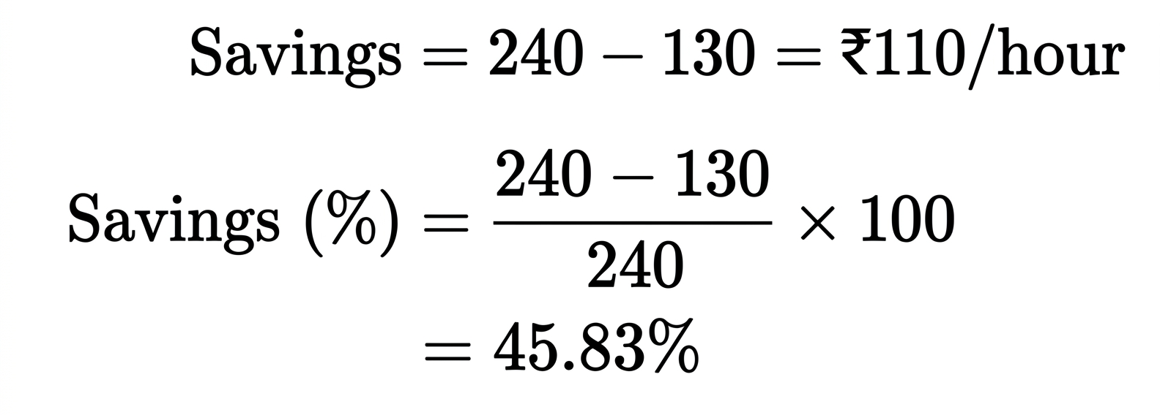

F. Further Analysis

F.1 Validation of Solution
The optimization solution was evaluated using the solver status, workload allocation, processing capacity, and total modeled cost.
The solver returned an optimal status for the supplied experimental dataset. The selected configuration consists of four T4 GPU instances and one A10G GPU instance, with a modeled aggregate processing capacity of 650 workload units per hour.
The total allocated workload is also 650 units, satisfying the specified demand requirement. The workload allocation is consistent with the GPU compatibility and processing-capacity parameters supplied to the model.
Additional validation should include checking every model constraint against the generated allocation, independently recalculating the objective value from the selected GPU counts, and confirming that no workload is assigned to an inactive or incompatible GPU type.
This validation establishes the feasibility of the mathematical solution under the model's assumptions. It does not establish real-world latency guarantees or production performance without appropriate benchmarking.

F.2 Sensitivity / What-If Analysis
Sensitivity analysis can be used to examine how changes in workload demand, GPU rental prices, and processing capacity influence the optimal GPU configuration and total cost.
The proposed analysis involves changing one input parameter at a time, rerunning the optimization model, and comparing the resulting objective value and allocation with the original solution.
The following scenarios are proposed:
- Increased workload demand: Increase demand to examine whether additional GPU instances are required and how total cost changes.
- Reduced workload demand: Decrease demand to determine whether fewer GPU instances can satisfy the requirements at a lower cost.
- GPU price variation: Increase or decrease the rental price of a selected GPU type to investigate whether the model switches to alternative GPU configurations.
- Processing-capacity variation: Modify estimated GPU processing capacity to examine the impact of performance changes on provisioning decisions.
- Resource availability variation: Restrict the maximum number of available instances of a GPU type to determine whether an alternative feasible configuration exists.
For each scenario, the model should record solver status, GPU provisioning, workload allocation, and total modeled cost. Percentage cost changes can then be calculated relative to the original solution.
Numerical outcomes for these scenarios should be reported only after the corresponding experiments have been executed. The current base-case result alone does not establish how the solution responds to these changes.

F.3 Comparison with Existing Method
The optimized solution is compared with a baseline strategy that provisions two A100 GPU instances for the same planning interval.
Under the experimental pricing assumptions, the baseline costs ₹240 per hour, whereas the optimized configuration costs ₹130 per hour.
The comparison is summarized below.
Evaluation metric | A100-only baseline | Optimized MILP
T4 instances | 0 | 4
A10G instances | 0 | 1
A100 instances | 2 | 0
Total hourly cost | ₹240 | ₹130
Workload demand | 650 units | 650 units
Modeled demand satisfaction | To be verified against baseline capacity | Satisfied
Relative cost reduction | — | 45.83%
The optimized model reduces modeled hourly expenditure by ₹110, equivalent to 45.83% of the baseline cost.
This comparison demonstrates the potential advantage of cost-aware GPU selection over a fixed, high-capacity GPU provisioning strategy. For a rigorous comparison, the baseline must also be verified to satisfy the same workload, memory, processing-capacity, and latency-feasibility requirements. If it does not, the comparison should be reported as a cost comparison rather than as an equivalent feasible-service comparison.

F.4 Limitations
The project has several limitations.
- Experimental input data: The results use illustrative input values rather than confidential enterprise workload traces or verified live cloud pricing.
- Simplified processing estimates: GPU processing capacity is represented through fixed estimates, whereas actual inference performance varies with model architecture, precision, context length, batch size, and concurrent requests.
- Simplified latency representation: The model uses estimated latency-feasibility parameters and does not fully simulate queueing delays, network overhead, or end-to-end response times.
- Memory compatibility assumptions: Memory feasibility is represented using predefined compatibility parameters rather than a detailed simulation of model weights, runtime allocations, and KV-cache usage.
- Simplified rental-cost model: The objective considers GPU rental expenditure and excludes other potential expenses such as storage, networking, model-hosting overhead, and startup charges.
- Demand assumptions: The model uses specified demand for each planning interval and does not automatically predict future demand.
- Limited baseline comparison: The A100-only baseline represents one alternative provisioning strategy and does not cover every possible industry allocation method.
These limitations define the scope of the current implementation and provide opportunities for further development.

F.5 Future Scope
The project can be extended in several directions.
- Real-world benchmarking: Collect measured throughput, memory consumption, and latency data for representative open-source LLMs on different GPU types.
- Dynamic provisioning: Incorporate GPU activation and deactivation decisions, startup delays, and associated costs.
- Advanced latency modelling: Introduce queueing models or benchmark-derived latency functions to represent concurrent workloads more accurately.
- Demand forecasting: Combine demand prediction with optimization to prepare GPU capacity for expected workload fluctuations.
- Additional GPU types: Expand the model to include more cloud GPU configurations and alternative cloud providers.
- Energy-aware optimization: Extend the objective to consider electricity consumption, energy efficiency, or carbon emissions where relevant data is available.
- Multi-objective optimization: Investigate trade-offs between rental cost, latency, resource utilization, and service reliability.
- Production evaluation: Test the model using real workload traces and compare its recommendations with existing production allocation strategies.
These extensions could improve the model's realism and support its application to larger and more dynamic AI inference environments.

